You will be going back to school soon!!
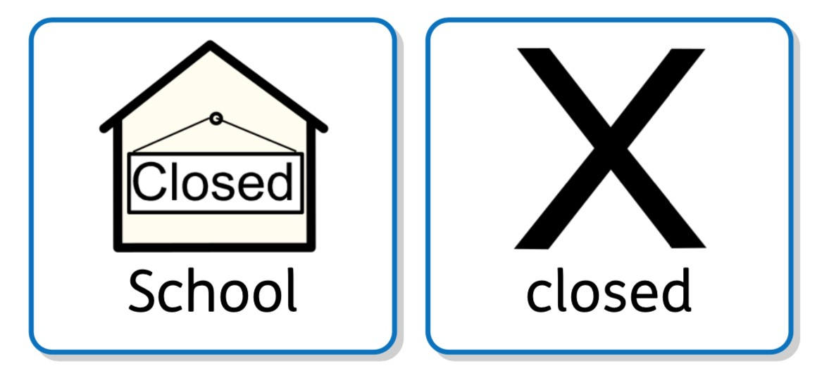
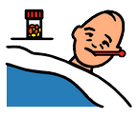
Since 23rd March 2020, most schools in England have closed to most of the children. It has been closed because of Coronavirus.

Some children still went to school each day because they have parents who work as key workers. Other children have been at home each day.

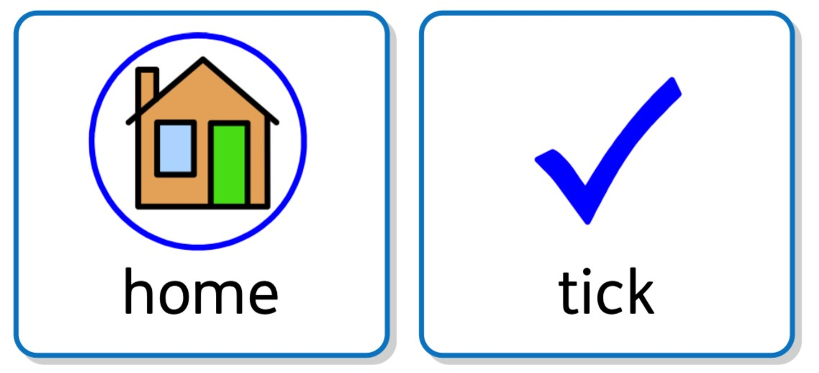
This time in lockdown has become a new normal for us all.

The government have now made the decision it is time for children to go back to school.
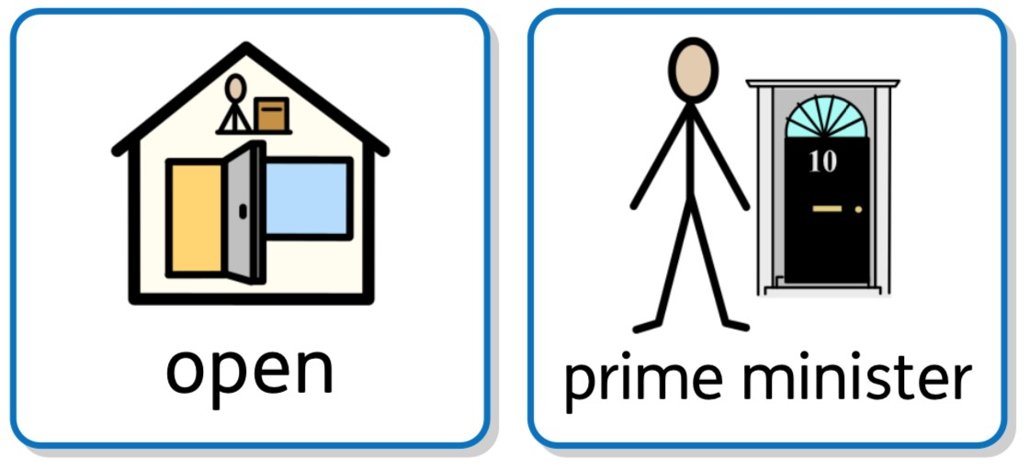

We will look forward to seeing you return, however some things might be different at school, but lots of things will still be the same.
You will go to school on:
Week 1
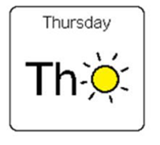or 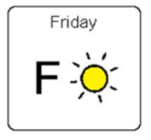
Then

Where possible please keep your distance from people!

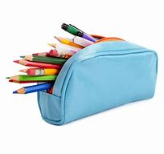
You will have your own pencil case and equipment.

You will only work and play with children in your class and Bubble
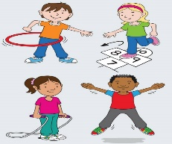

If you need to cough or sneeze, make sure you cover your mouth or nose.
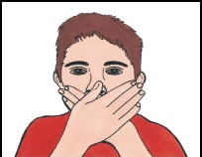

Make sure you wash your hands with soap and water or hand sanitiser lots throughout the day.
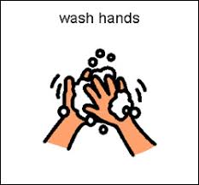

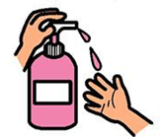

Have a look on the website for your Class Teacher and TA !

Going to school will be OK!

