Week beginning 11th May

English skills
English daily online lessons : The following websites have a whole week of English lessons you can work through every day:
https://www.bbc.co.uk/bitesize/dailylessons

https://www.thenational.academy/online-classroom

Also for a range of fun English games you can try:
https://www.topmarks.co.uk/

Remember to keep reading your books at home. Oxford have an E-library where you can choose online books to read:
https://home.oxfordowl.co.uk/books/free-ebooks/

The following activities will help you to keep practising your handwriting and you will need to complete in your workbook.
Monday 11th May Comprehension
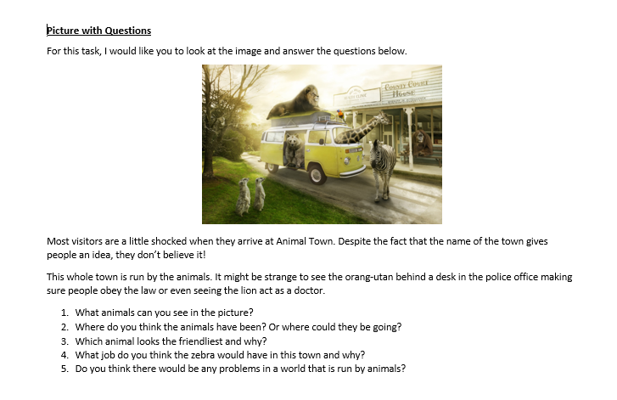
Vocabulary
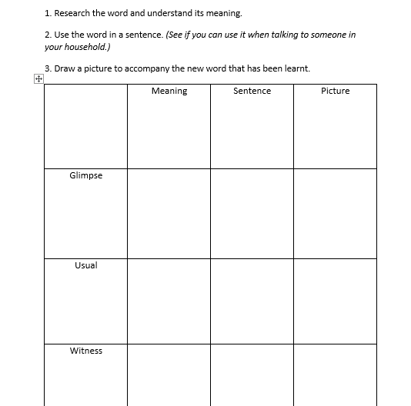

Reading task
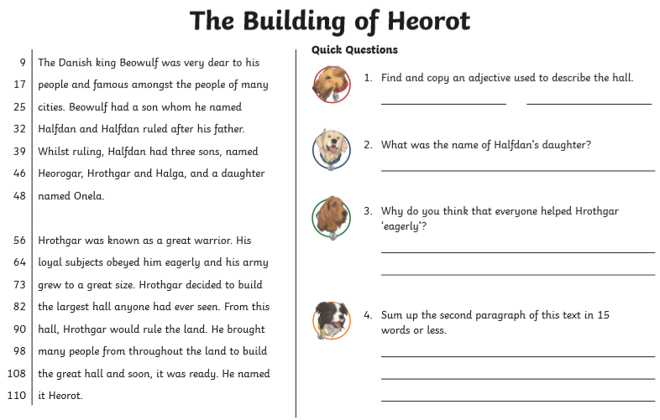
Tuesday 12 th May
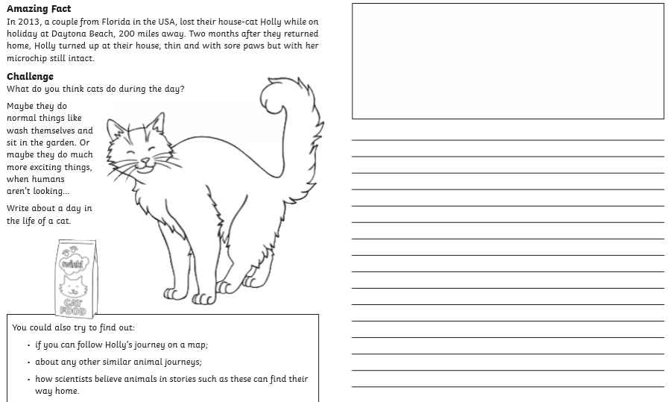

Wednesday 13^{h} May
Grammar
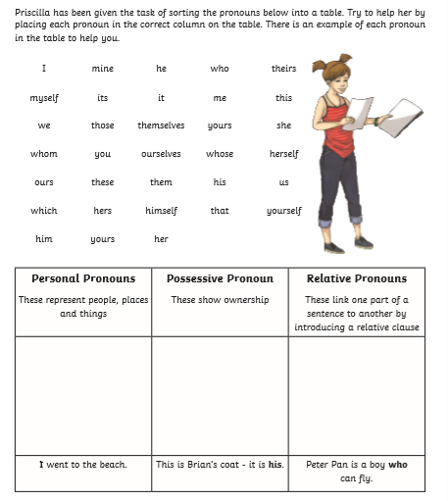
Reading task
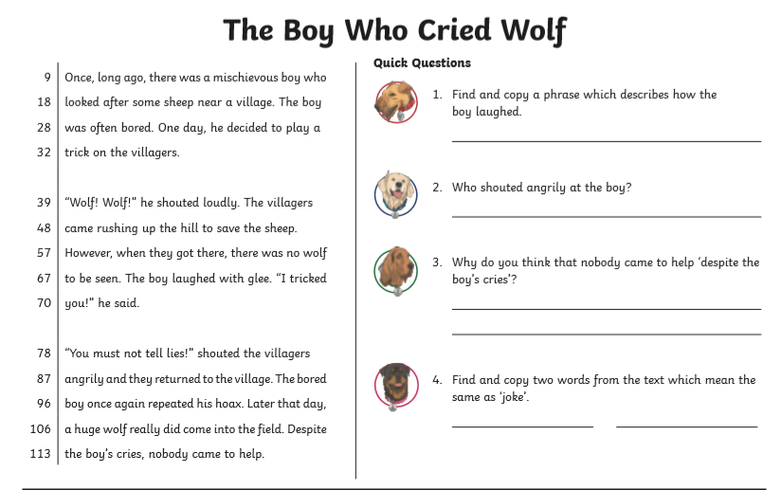

Thursday 14th May
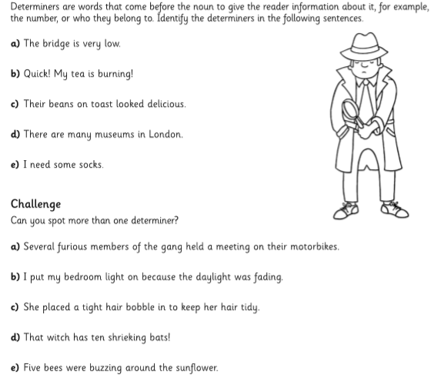

Reading task
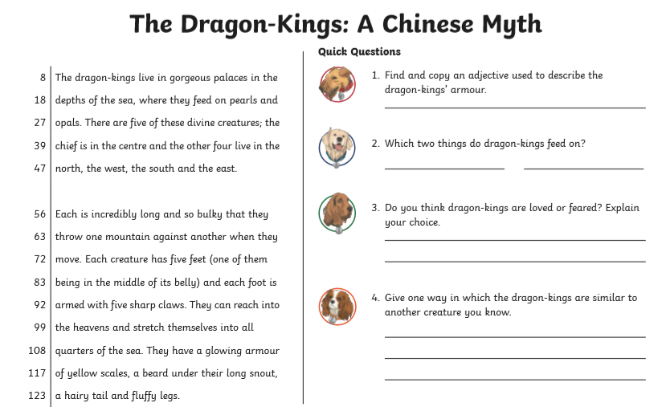

Friday 15th May

Spelling (continue to practise these year group spellings)
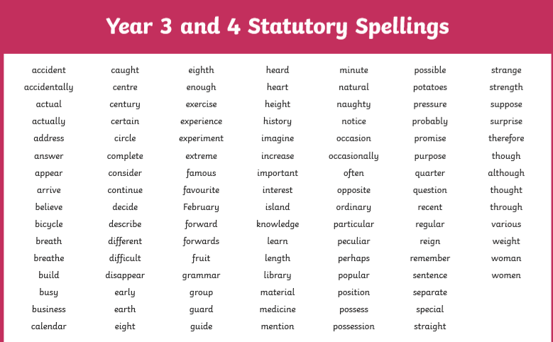
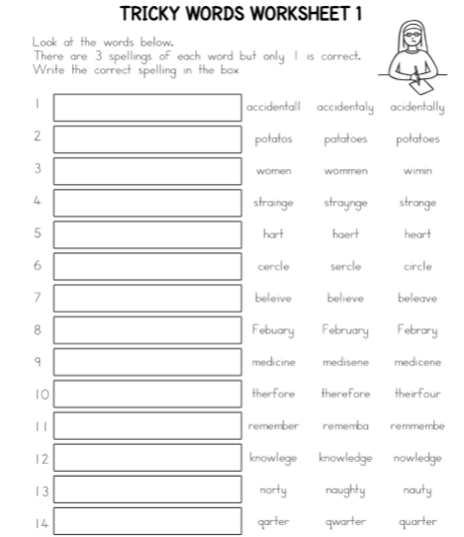
Writing
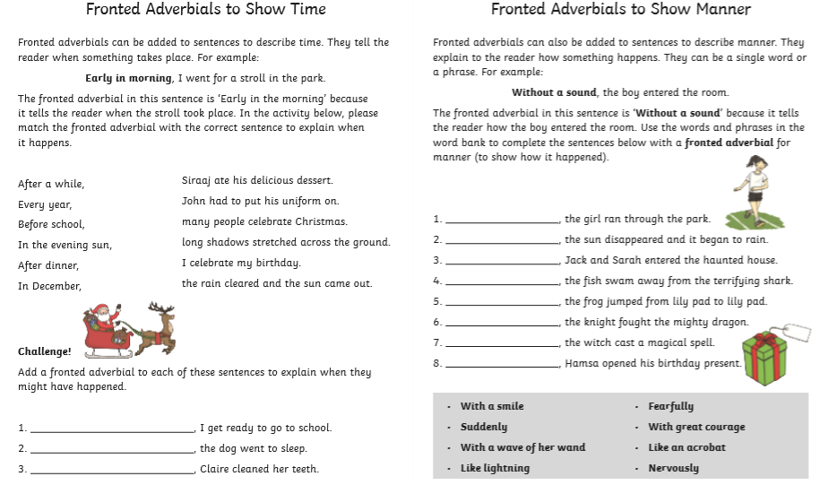
Reading
