Monday 18th May

Further English skills

English daily online lessons : The following websites have a whole week of English lessons you can work through every day:
https://www.bbc.co.uk/bitesize/dailylessons

https://www.thenational.academy/online-classroom

Also for a range of fun English games you can try:
https://www.topmarks.co.uk/

Remember to keep reading your books at home. Oxford have an E-library where you can choose online books to read:
https://home.oxfordowl.co.uk/books/free-ebooks/

Reading comprehension
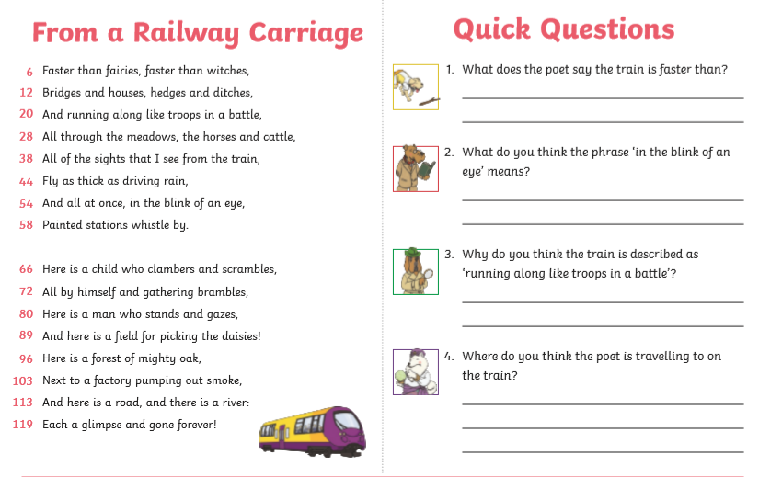

Writing
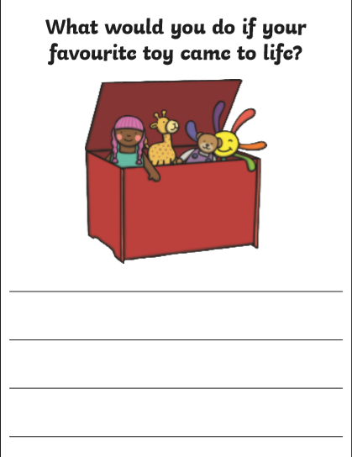
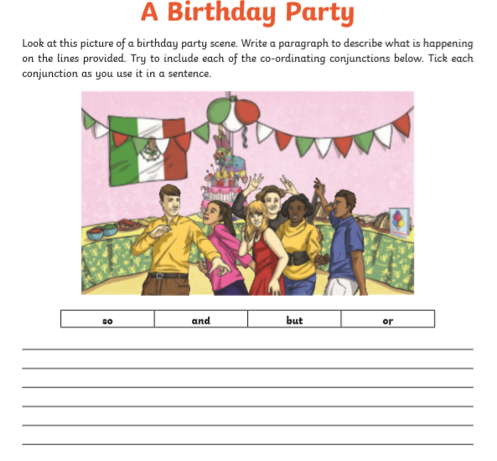

Reading task
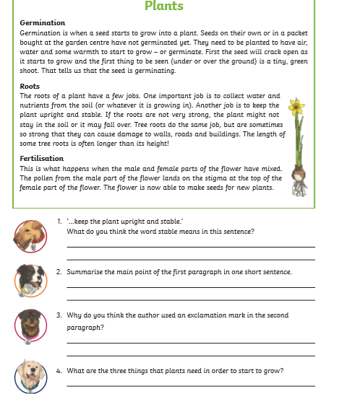

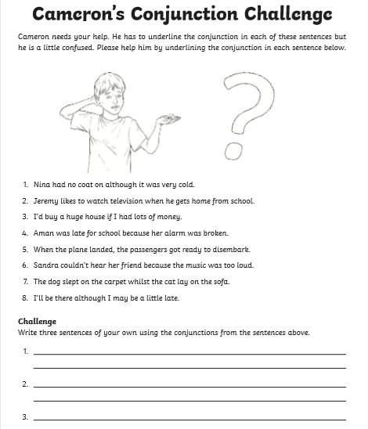

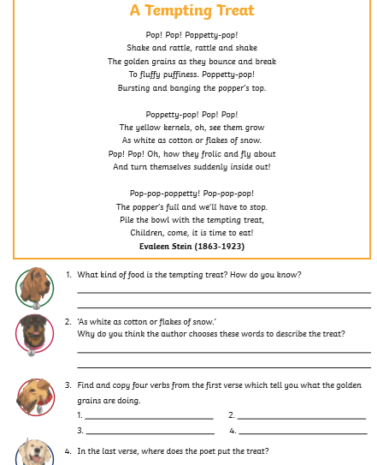

Grammar
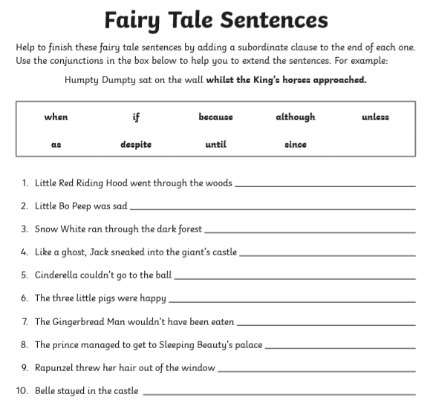

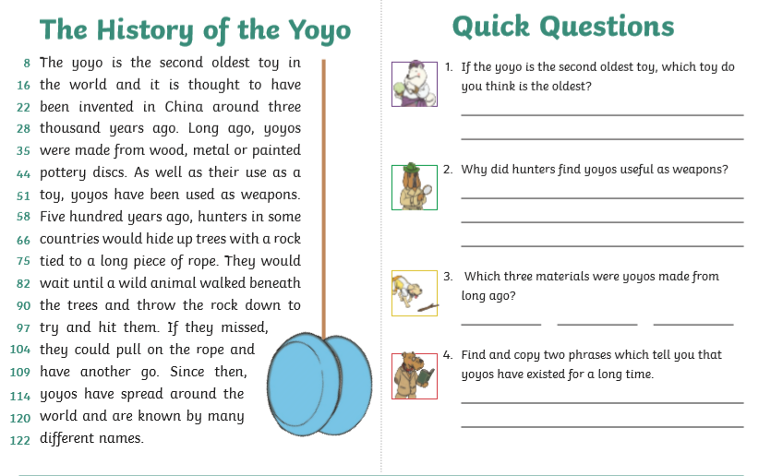

Spelling (continue to practise these year group spellings)

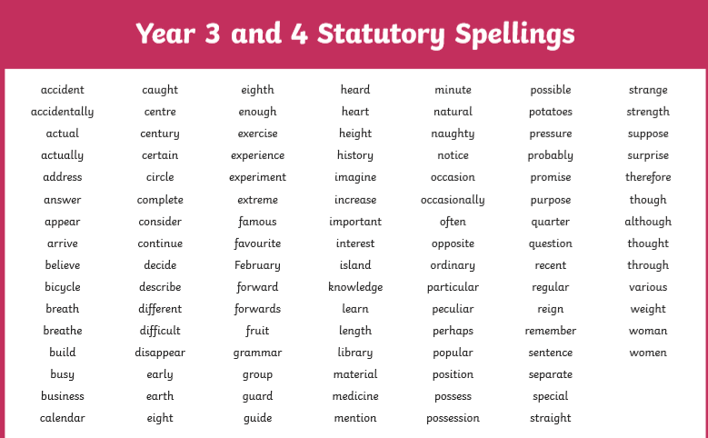

Grammar
