Monday 18th May

English skills

English daily online lessons : The following websites have a whole week of English lessons you can work through every day:
https://www.bbc.co.uk/bitesize/dailylessons

https://www.thenational.academy/online-classroom

Also for a range of fun English games you can try:
https://www.topmarks.co.uk/

Remember to keep reading your books at home. Oxford have an E-library where you can choose online books to read:
https://home.oxfordowl.co.uk/books/free-ebooks/

The following activities will help you to keep practising your handwriting and you will need to complete in your workbook .

Reading comprehension
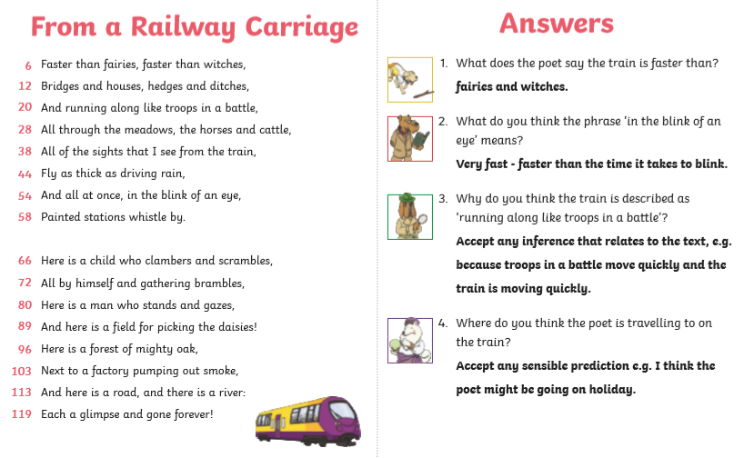

Writing
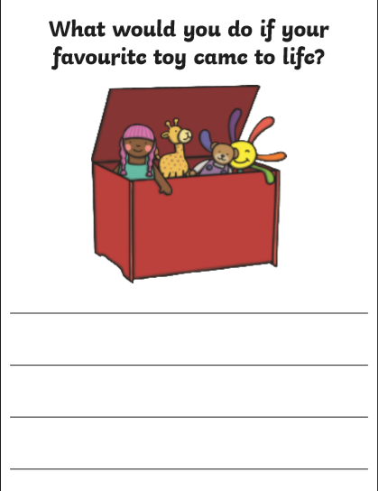
Have you included capital letters and full stops?
Have you used interesting adjectives?

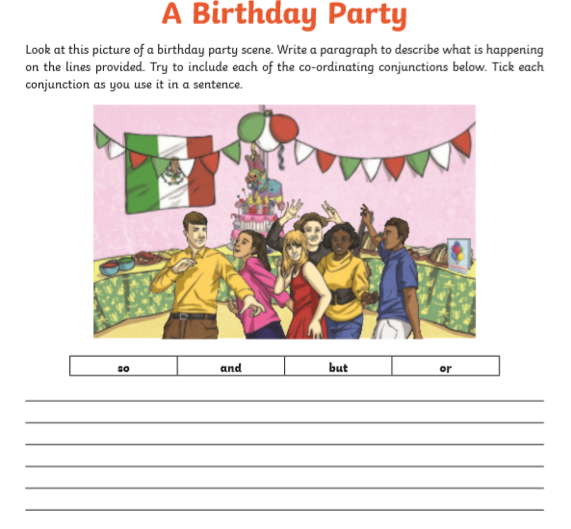

Make sure your sentences make sense and you have included all of the conjunctions.

Reading task
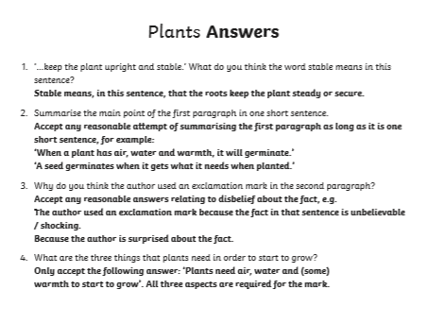

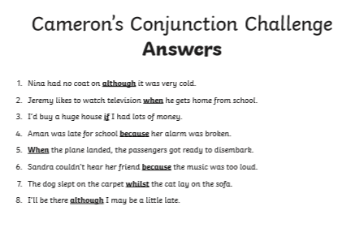

Reading task

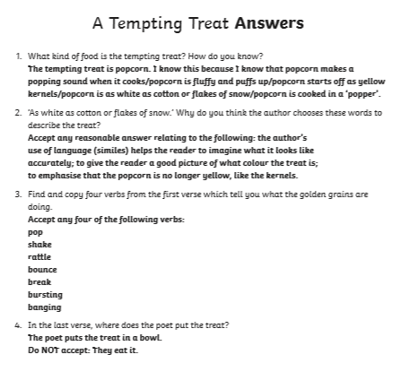

Grammar
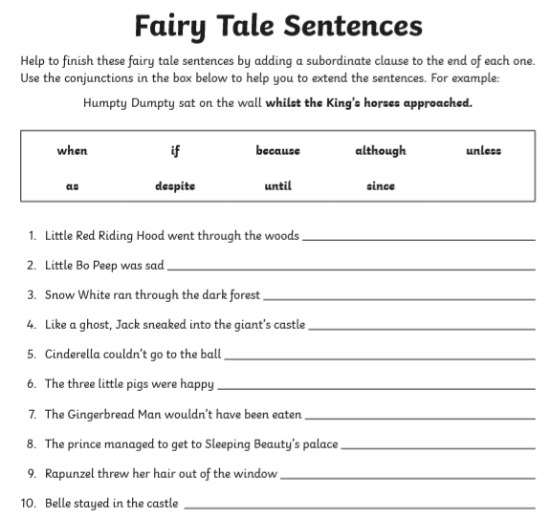

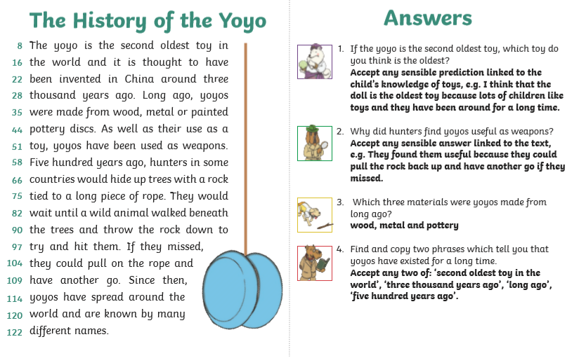

Spelling (continue to practise these year group spellings)

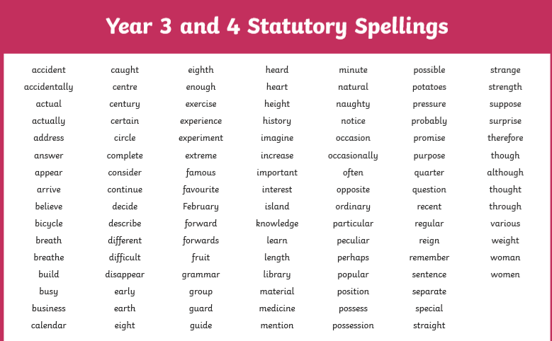

Grammar
