Week beginning 1st June
English

For additional activities

English daily online lessons: The following websites have a whole week of English lessons you can work through every day:
https://www.bbc.co.uk/bitesize/dailylessons
https://www.thenational.academy/online-classroom

Also ,for a range of fun English games you can try:
https://www.topmarks.co.uk/

Remember to keep reading your books at home. Oxford have an E-library where you can choose online books to read:

https://home.oxfordowl.co.uk/books/free-ebooks/

Daily Phonics lessons
https://www.ruthmiskin.com/en/find-out-more/parents/
Daily phonics practise and story time sessions
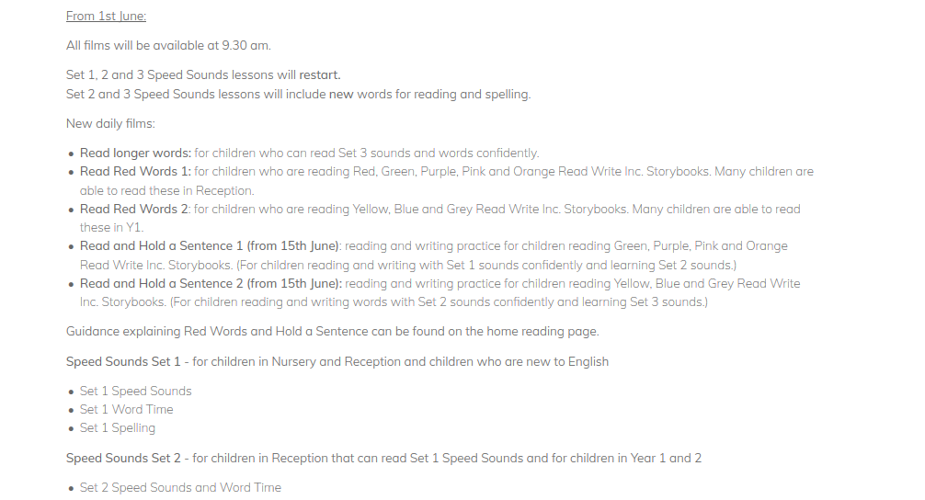

We also would like you to keep practising your handwriting skills, so the following tasks should be used as a guide and can be completed in your workbooks:
Reading
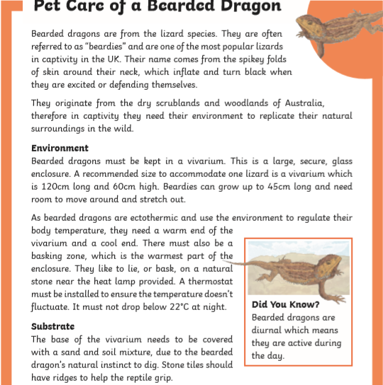
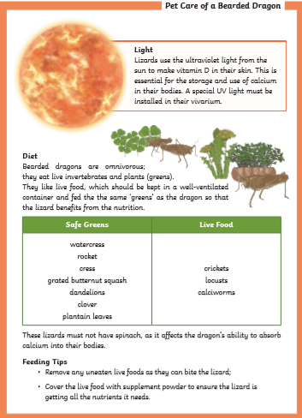
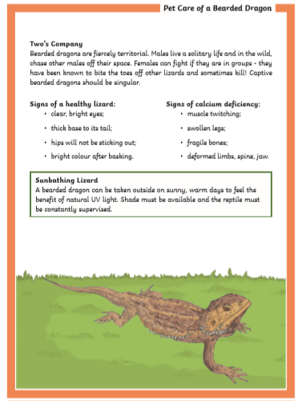

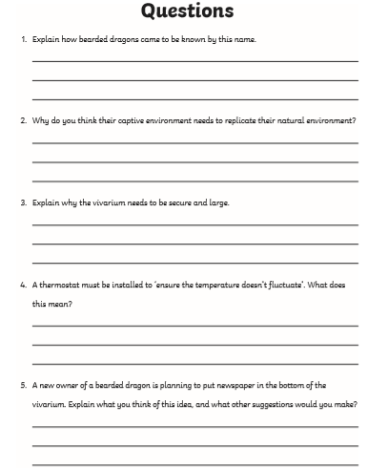
Writing
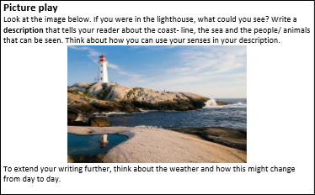
_____________________________________________________________________________________________________________________________________________________________________________________________________________________________________________________________________________________________________________________________________________________________________________________________________________________________________________________________________________________________________________________________________________________________________________________________________________________________________________________________________________________________________________________________________________________________________________________________________________________________________________________________________________________________________________________________________________________________________________________________________________________________________________________________________________________________________________________________________________________________________

Draw a picture that matches your writing.

Grammar
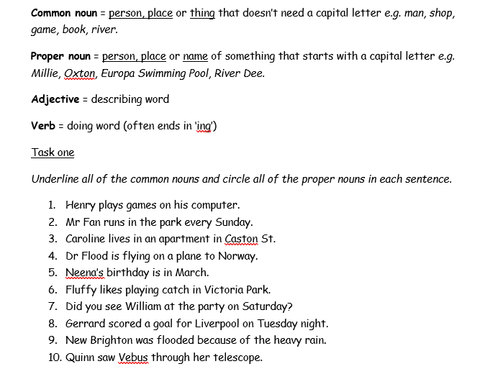

Reading
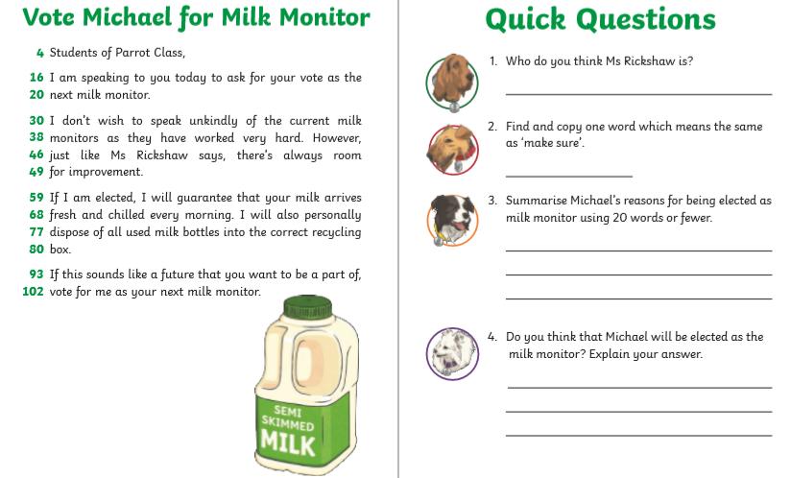

Spelling
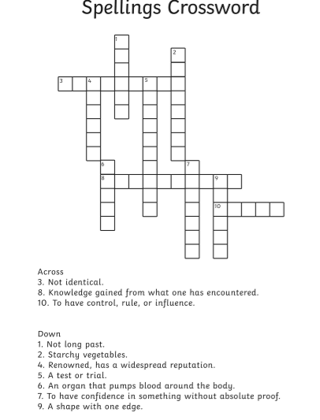

Grammar
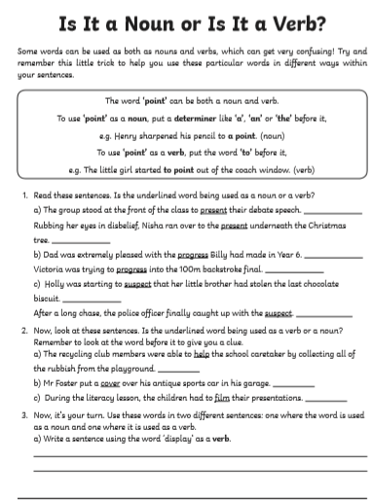

Grammar
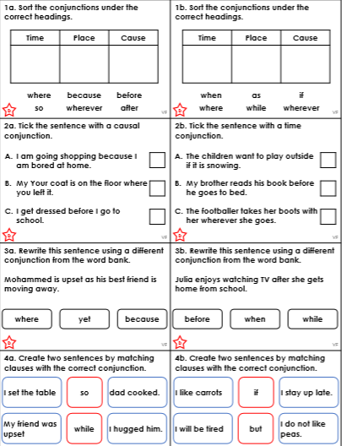

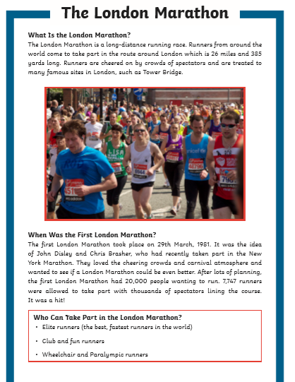

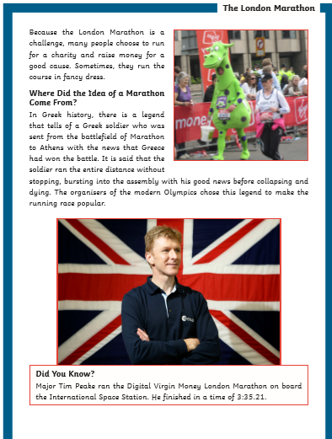
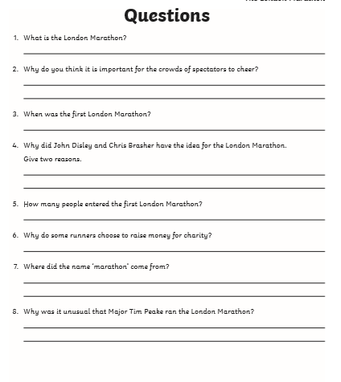

Grammar
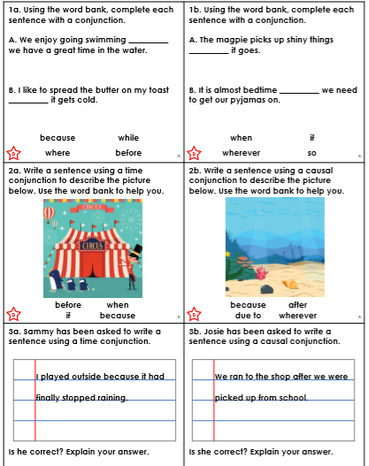

Spelling
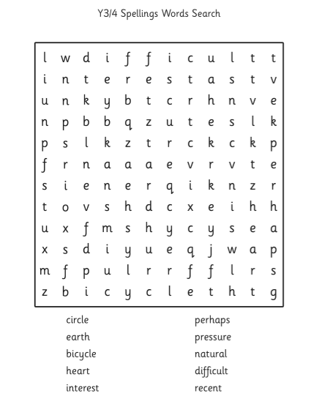

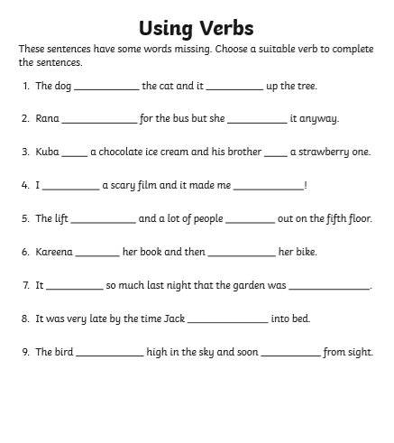

Sentences
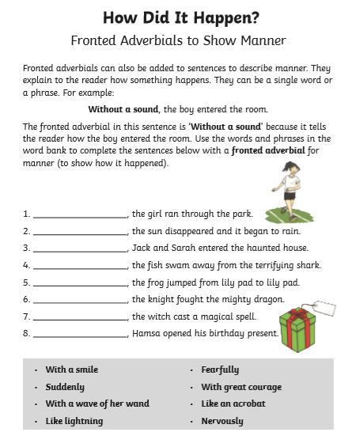

Grammar
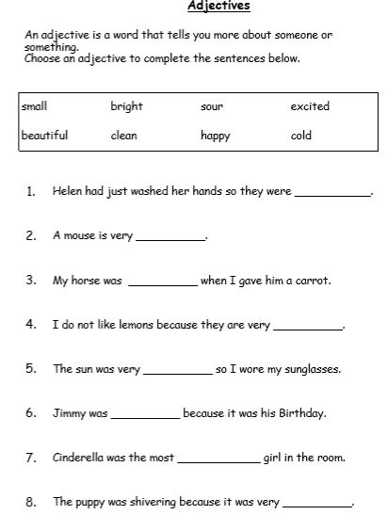

Spelling
