Week beginning 1st June
English

English daily online lessons: The following websites have a whole week of English lessons you can work through every day:
https://www.bbc.co.uk/bitesize/dailylessons
https://www.thenational.academy/online-classroom

Also ,for a range of fun English games you can try:
https://www.topmarks.co.uk/

Remember to keep reading your books at home. Oxford have an E-library where you can choose online books to read:

https://home.oxfordowl.co.uk/books/free-ebooks/

Daily Phonics lessons
https://www.ruthmiskin.com/en/find-out-more/parents/
Daily phonics practise and story time sessions
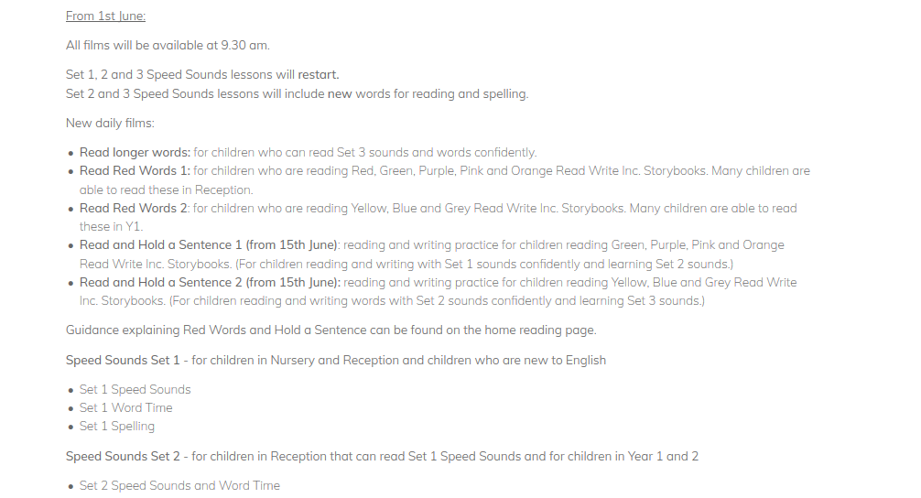

We also would like you to keep practising your handwriting skills, so the following tasks should be used as a guide and can be completed in your workbooks:
Monday 1st June Reading
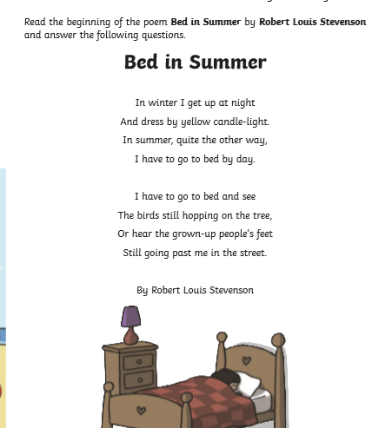
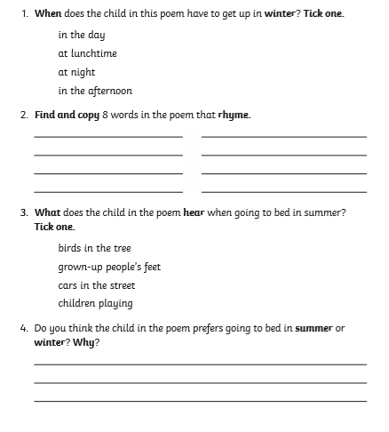
Writing
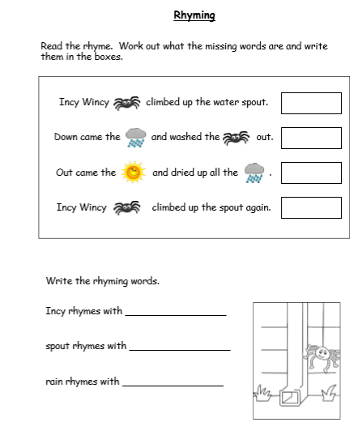

Sorting
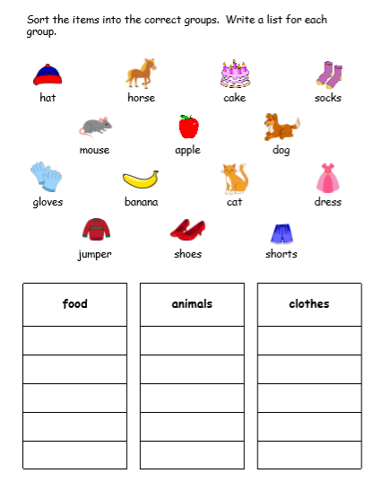

Grammar
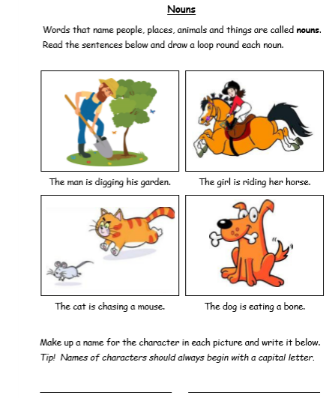

Tuesday 2nd June Reading
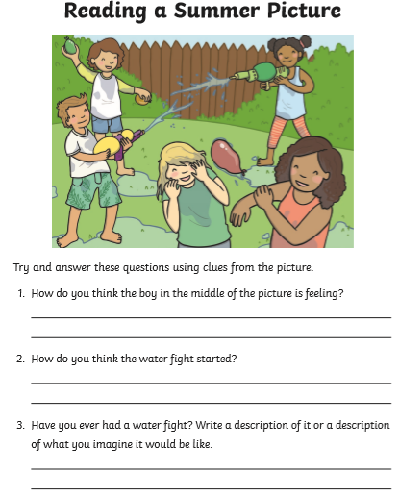

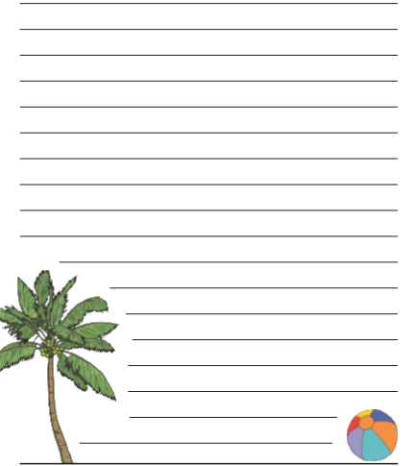
Spelling
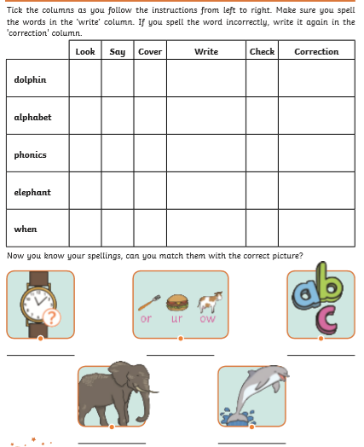

Grammar
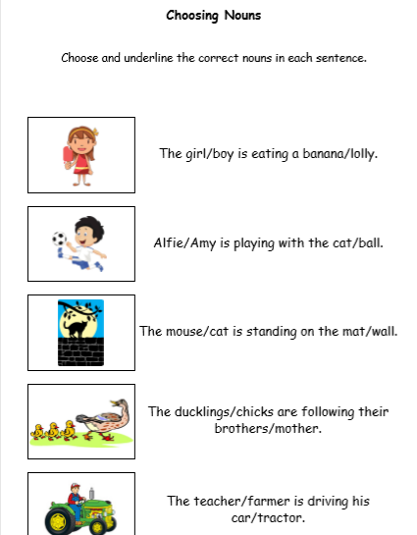

Grammar
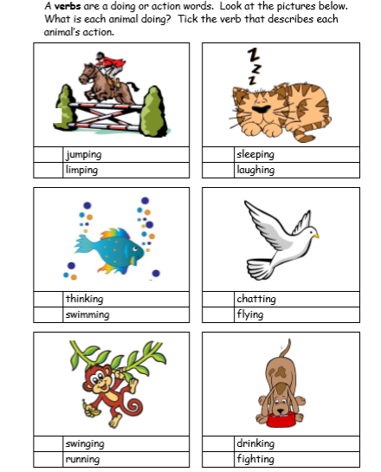

Wednesday 3rd June Reading
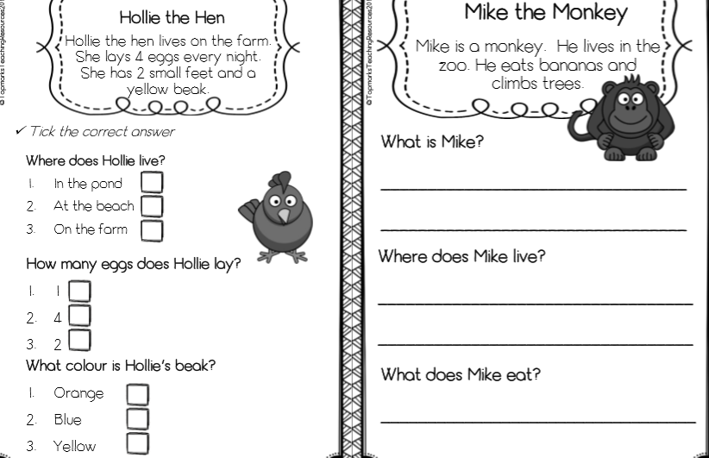

Grammar
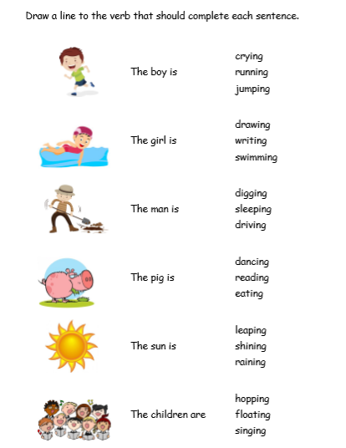

Spelling
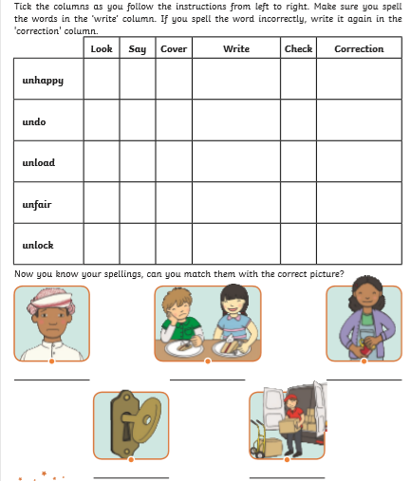

Thursday 4th June Phonics
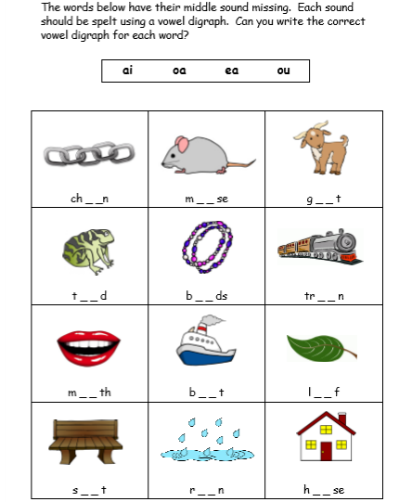
Sentences
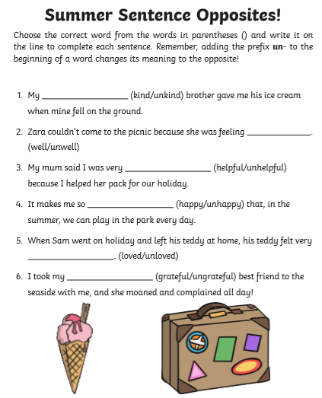
Reading
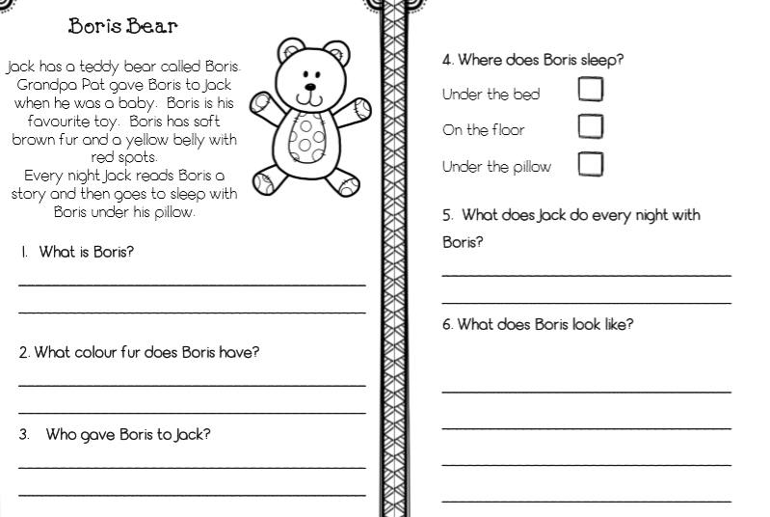

Friday 5th June
Grammar
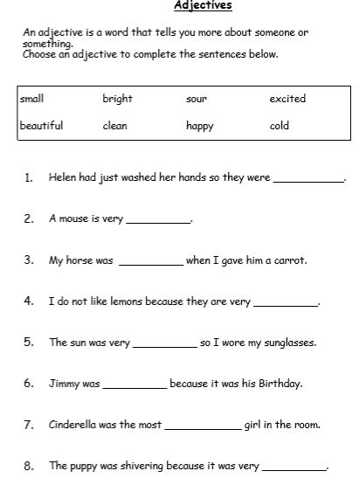

Reading
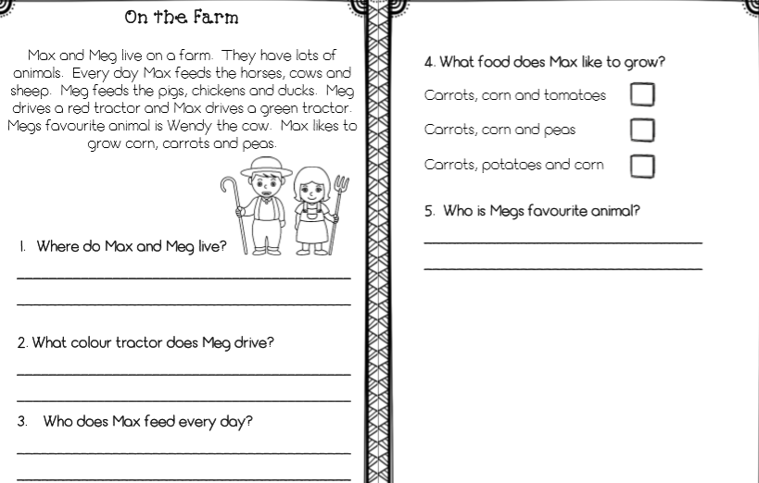
Spelling
