Week beginning 18th May
English-answers

English daily online lessons: The following websites have a whole week of English lessons you can work through every day:
https://www.bbc.co.uk/bitesize/dailylessons
https://www.thenational.academy/online-classroom

Also ,for a range of fun English games you can try:
https://www.topmarks.co.uk/

Remember to keep reading your books at home. Oxford have an E-library where you can choose online books to read:

https://home.oxfordowl.co.uk/books/free-ebooks/

Daily Phonics lessons
https://www.ruthmiskin.com/en/find-out-more/parents/
Daily phonics practise and story time sessions
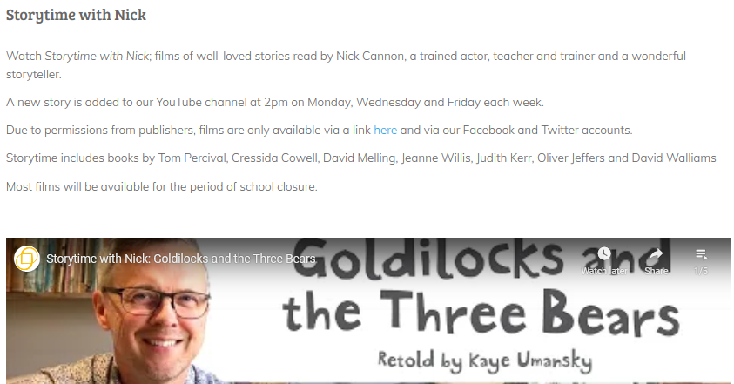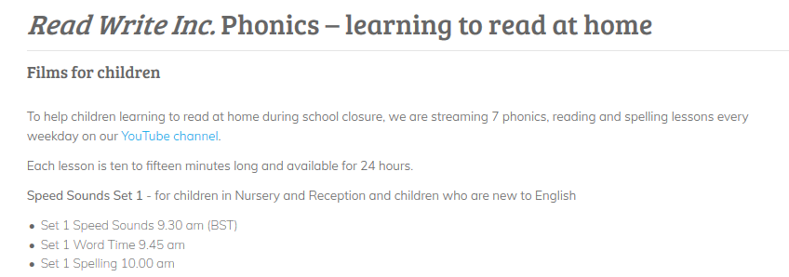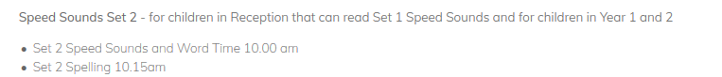
We also would like you to keep practising your handwriting skills, so the following tasks should be used as a guide and can be completed in your workbooks:
Monday 18th May Writing

Monday, Tuesday,Wednesday, Thursday, Friday, Saturday, Sunday.

Reading
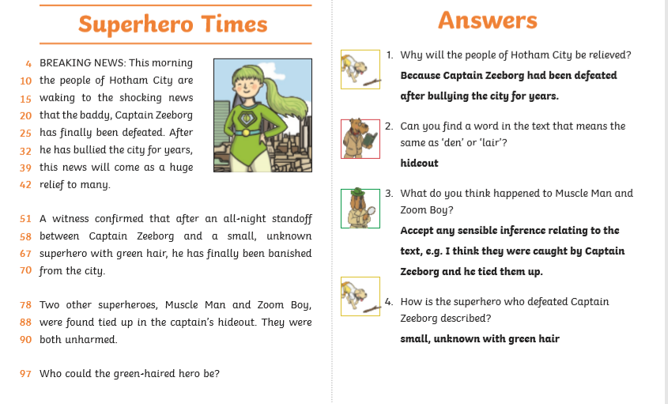

Grammar

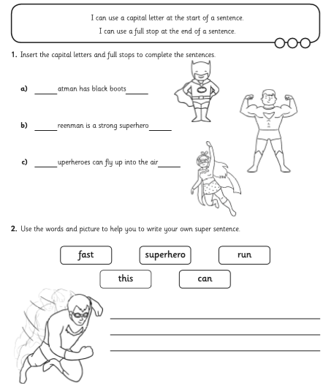
All sentences to begin with a capital letter and end with a full stop.

Reading
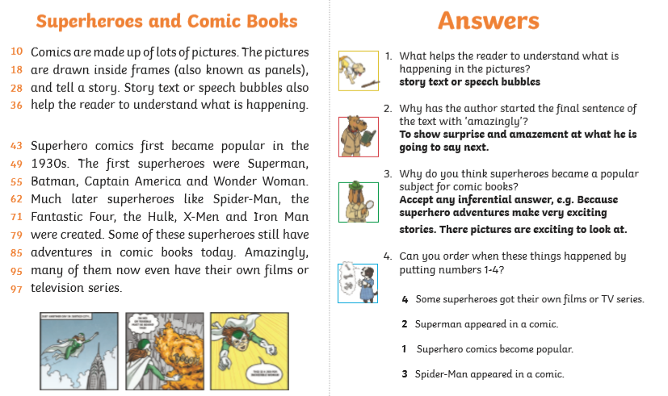

Tuesday 19th May
Punctuation
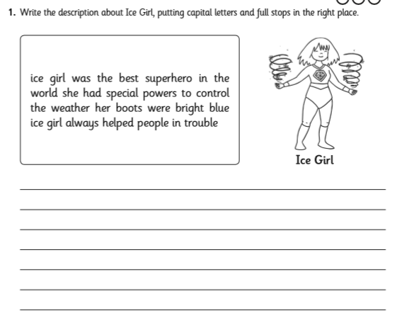
Ice girl was the best superhero in the world. She had special powers to control the weather. Her boots were bright blue. Ice girl always helped people in trouble.

Reading task
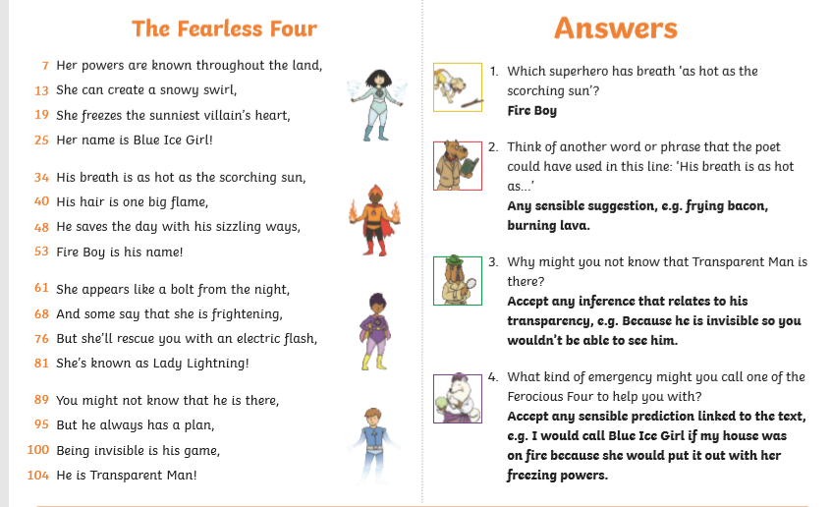

Spelling
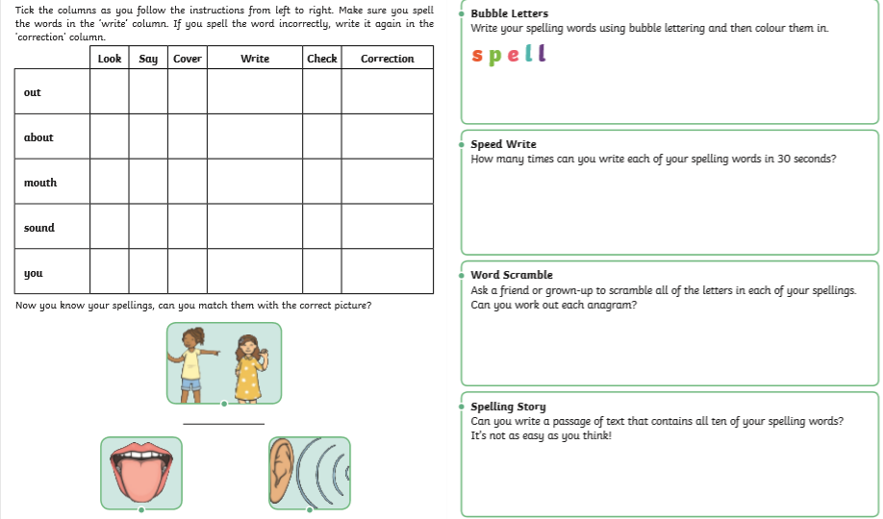

Wednesday 20th May Writing
Use some of these to create your own Superhero:
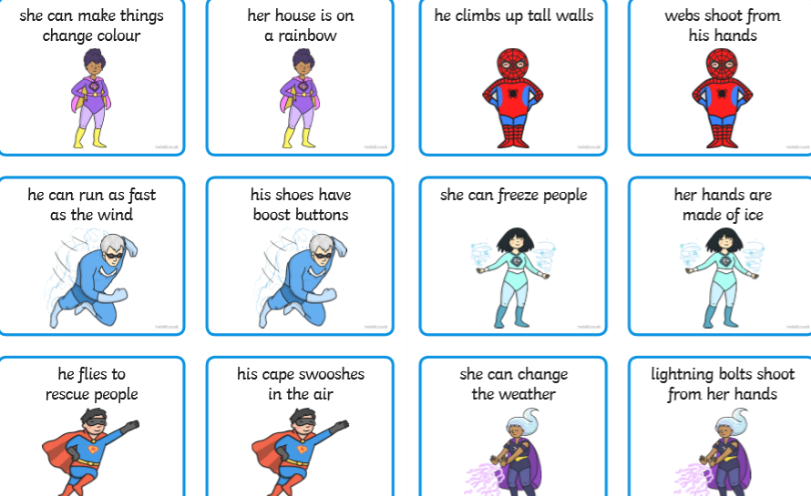
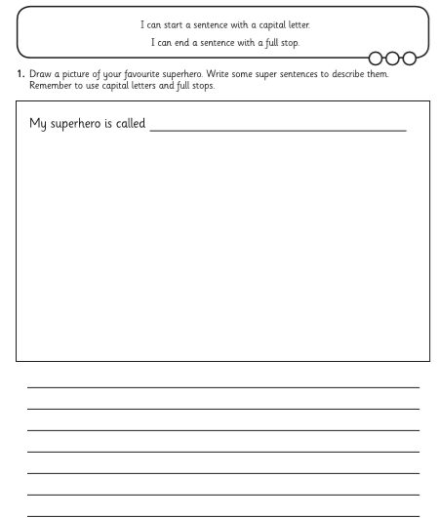
Check you have used capital letters and full stops.

Thursday 21st May
Reading task
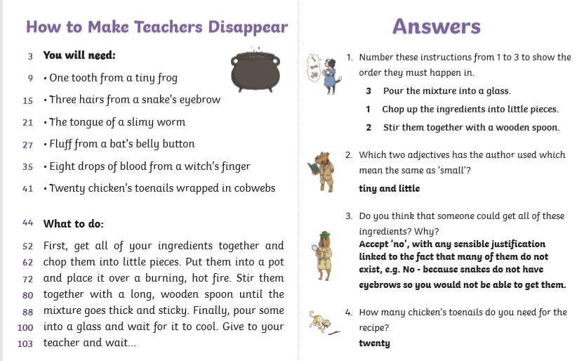
Friday 22nd May
Writing task
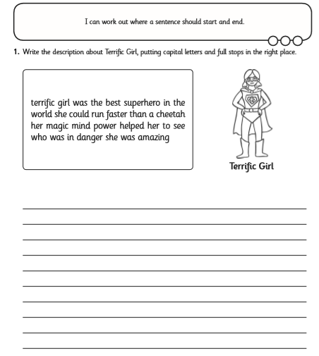
Terrific girl was the best superhero in the world. She could run faster than a cheetah. Her magic power helped her to see who was in danger. She was amazing.
Reading task
