Week beginning 11th May

English skills
English daily online lessons : The following websites have a whole week of English lessons you can work through every day:
https://www.bbc.co.uk/bitesize/dailylessons

https://www.thenational.academy/online-classroom

Also for a range of fun English games you can try:
https://www.topmarks.co.uk/

Remember to keep reading your books at home. Oxford have an E-library where you can choose online books to read:
https://home.oxfordowl.co.uk/books/free-ebooks/

The following activities will help you to keep practising your handwriting and you will need to complete in your workbook.
Monday 11th May Comprehension
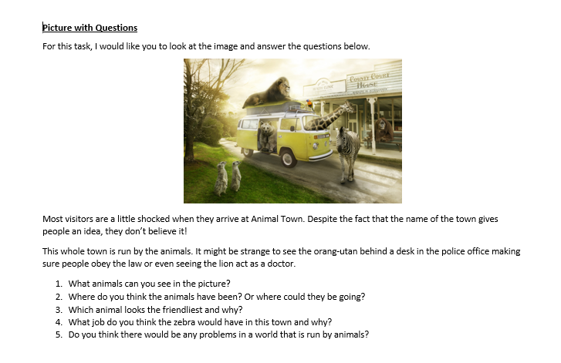
The answers to these questions will be different and link to the image.

Vocabulary
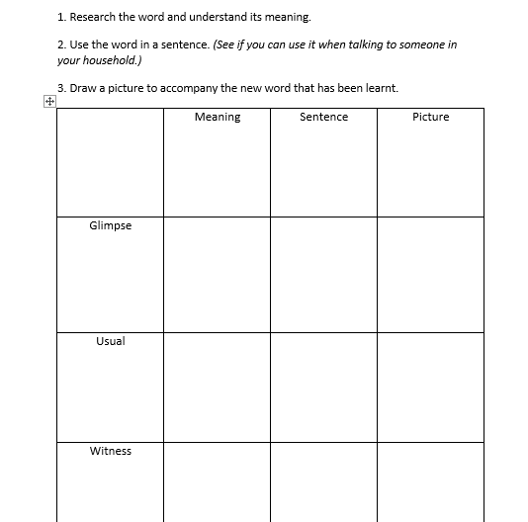
- Glimpse-a momentary or partial view.
"she caught a glimpse of the ocean"
- Usual-habitually or typically occurring or done; customary.
"he carried out his usual evening routine"
- Witness- a person who sees an event, typically a crime or accident, take place.
"police are appealing for witnesses to the accident
Reading task
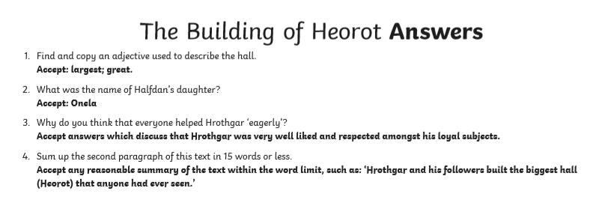

Tuesday 12 th May
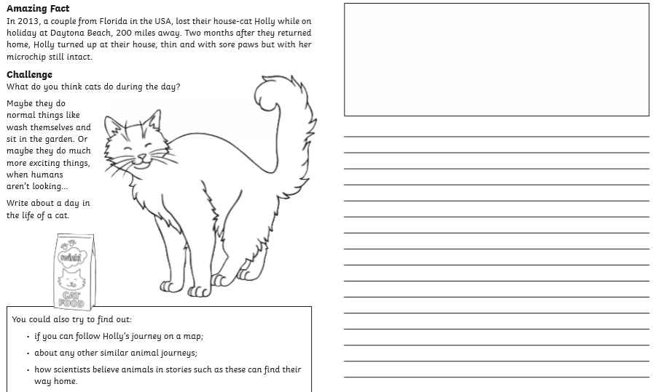
Answers will be different

Wednesday 13^{h} May
Grammar
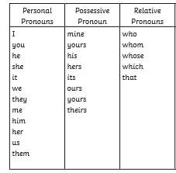

Reading task
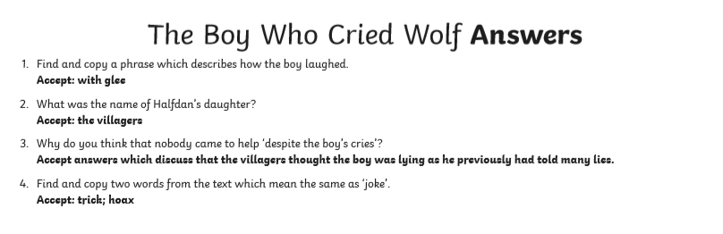

Thursday 14th May
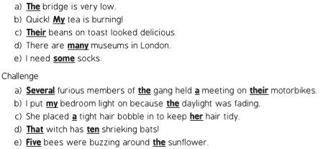

Reading task
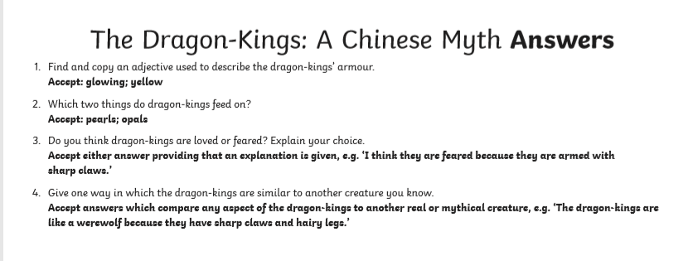

Friday 15th May

Spelling (continue to practise these year group spellings)
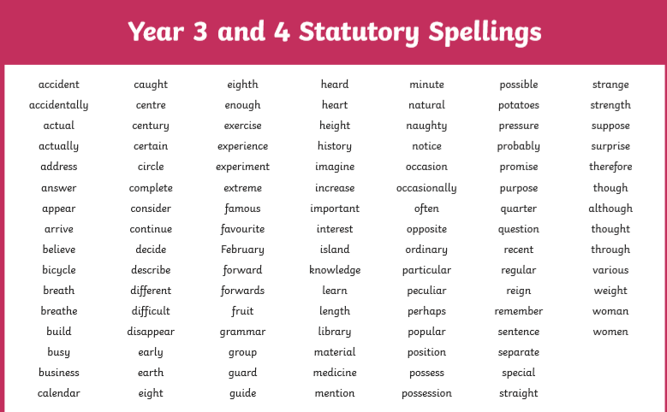
accidentally
Potatoes
Women
Strange
Heart
Circle
Believe
February
Medicine
Therefore
Remember
Knowledge
Naughty
Quarter

Writing
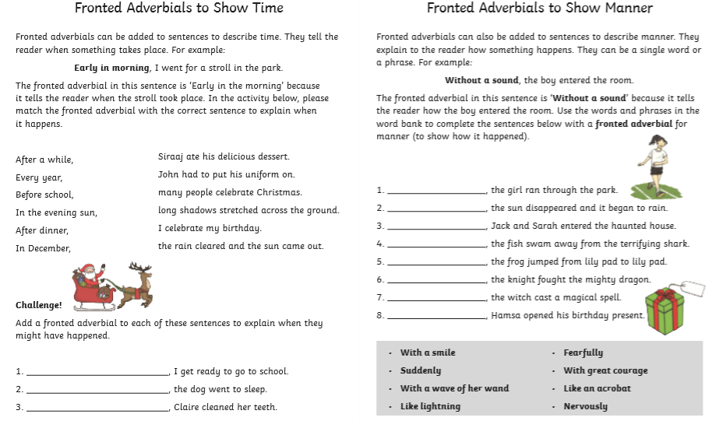
These answers can vary-check for sense.

Reading
