Monday 4th May

English skills
English daily online lessons : The following websites have a whole week of English lessons you can work through every day:
https://www.bbc.co.uk/bitesize/dailylessons

https://www.thenational.academy/online-classroom

Also for a range of fun English games you can try:
https://www.topmarks.co.uk/

Remember to keep reading your books at home. Oxford have an E-library where you can choose online books to read:
https://home.oxfordowl.co.uk/books/free-ebooks/

The following activities will help you to keep practising your handwriting and you will need to complete in your workbook.
Reading comprehension
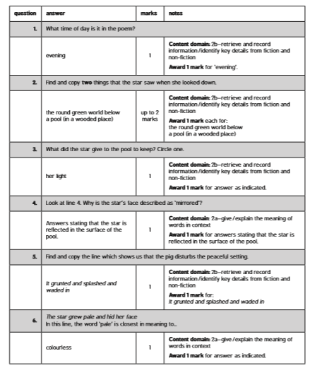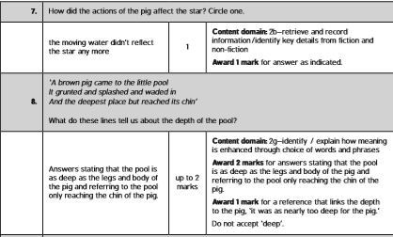
Grammar
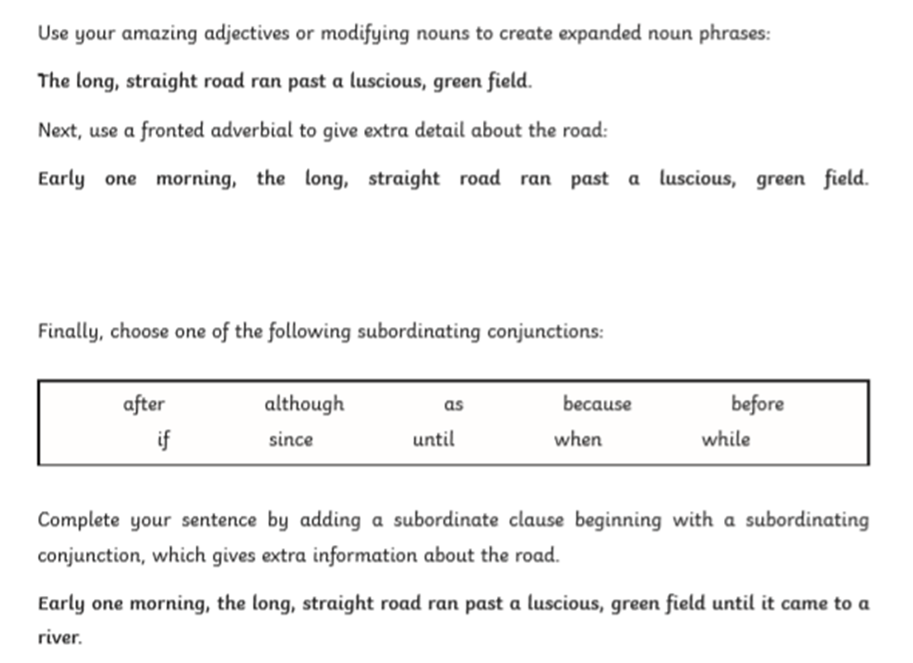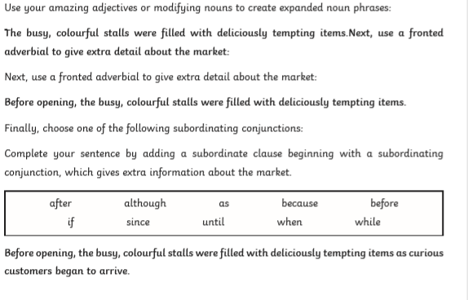

Reading task
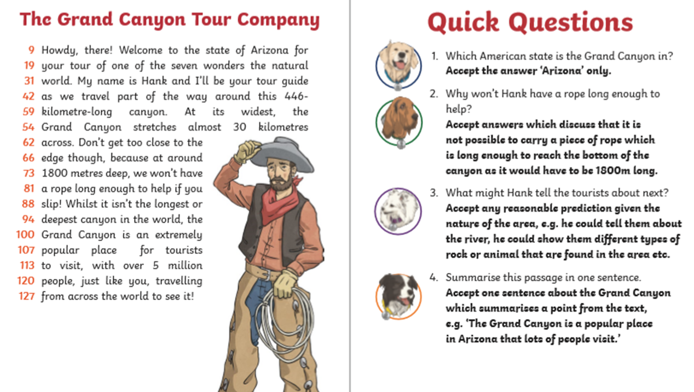

Tuesday 5th May
Grammar
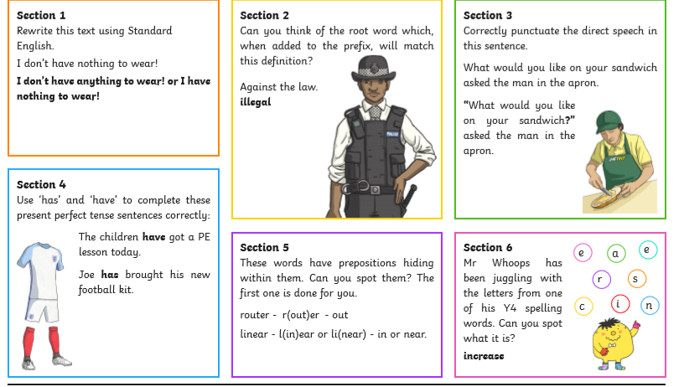

Reading task
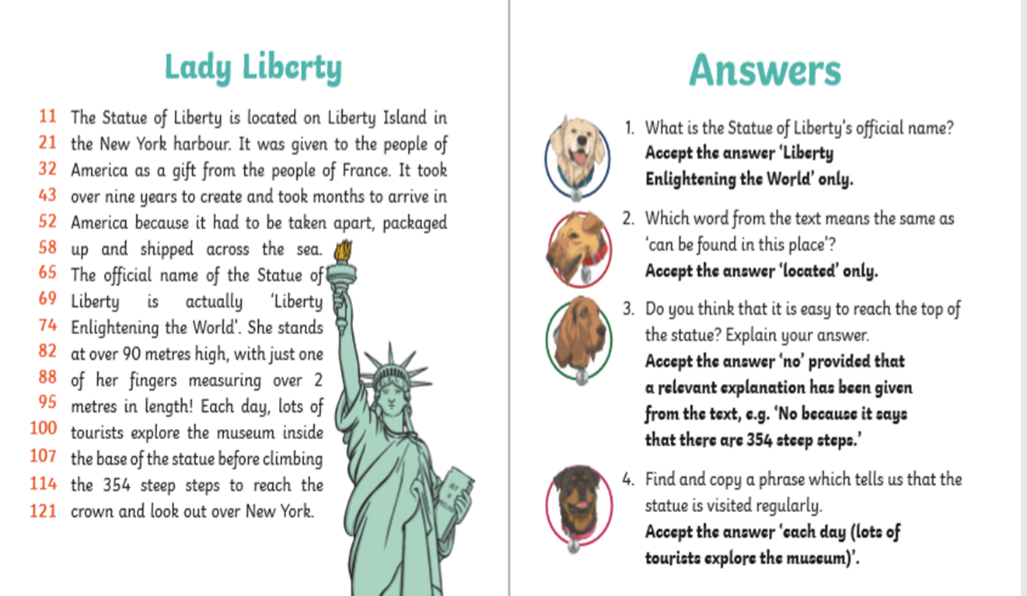

Wednesday 6th May
Grammar

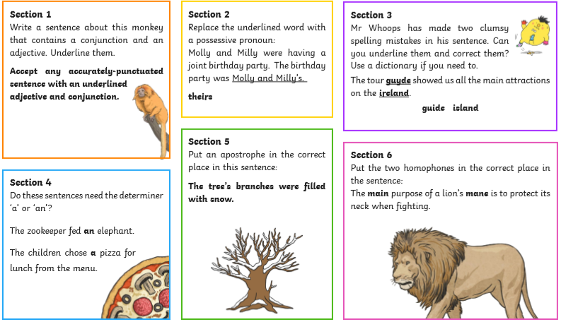

Reading task
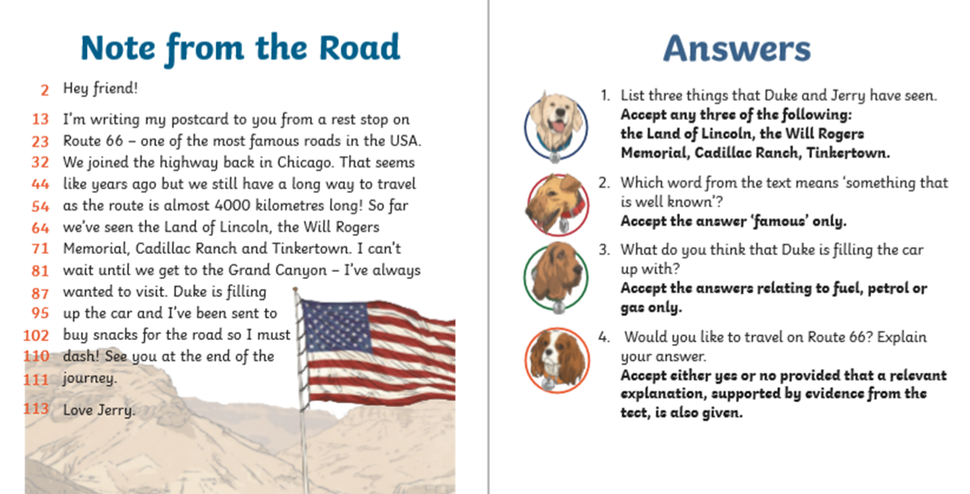

Thursday 7th May. Writing task
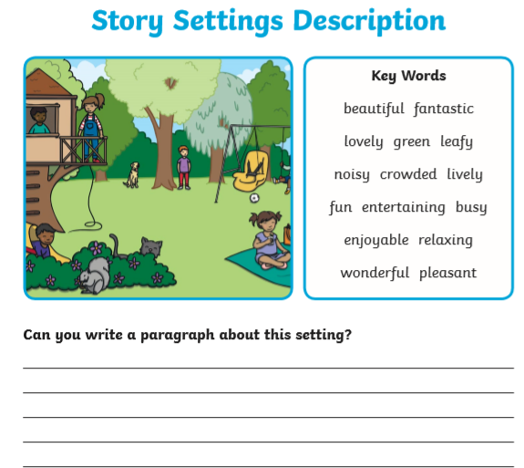

Reading task
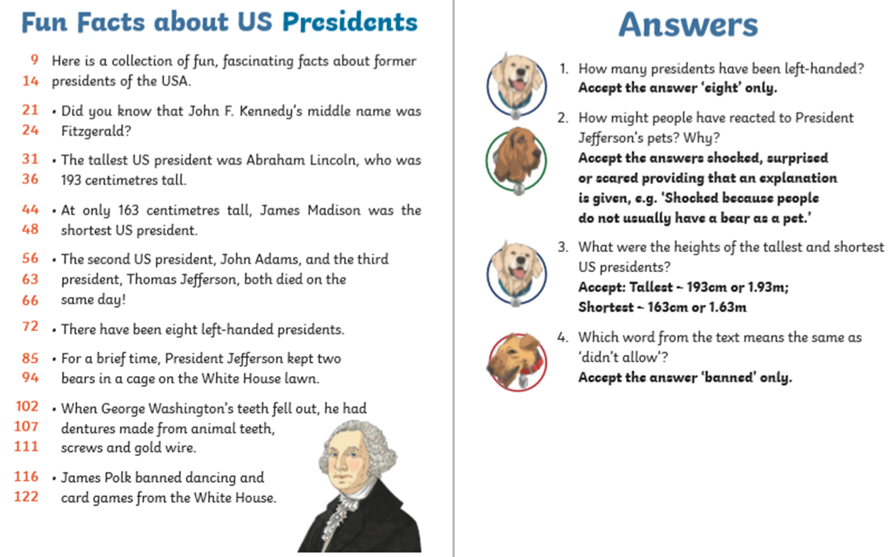

Friday 5th May

Spelling (continue to practise these year group spellings)
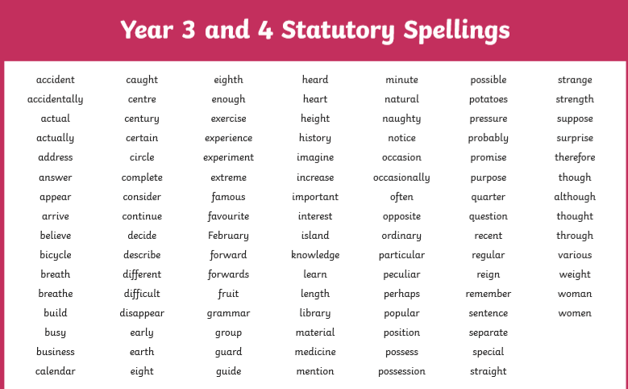
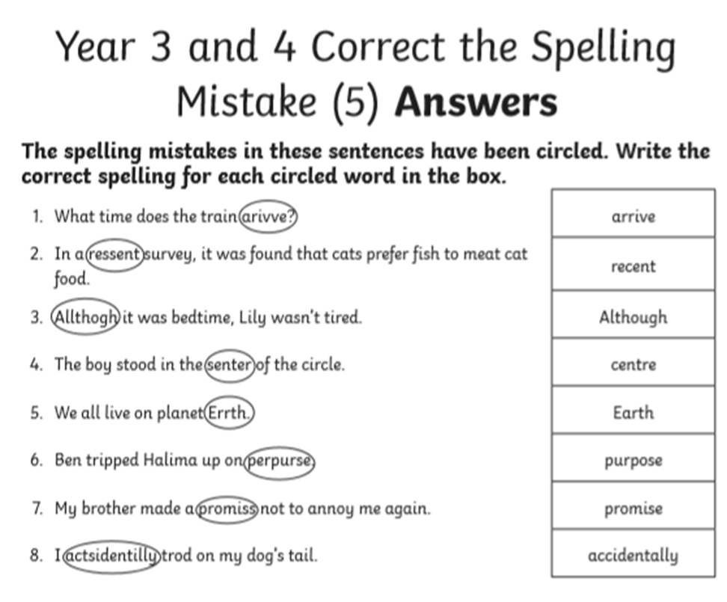

Reading
