1.6.20
English
Reading
Read the text and answer the questions.
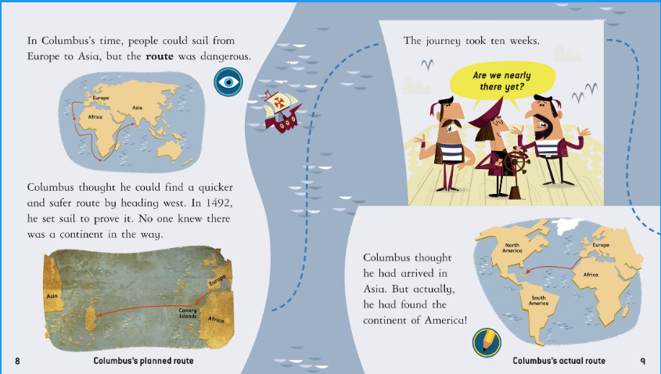
- Why do you think the route was dangerous from Europe to Asia?
- Which direction did Columbus head?
- How long did the journey take?
- Where did Columbus actually land?
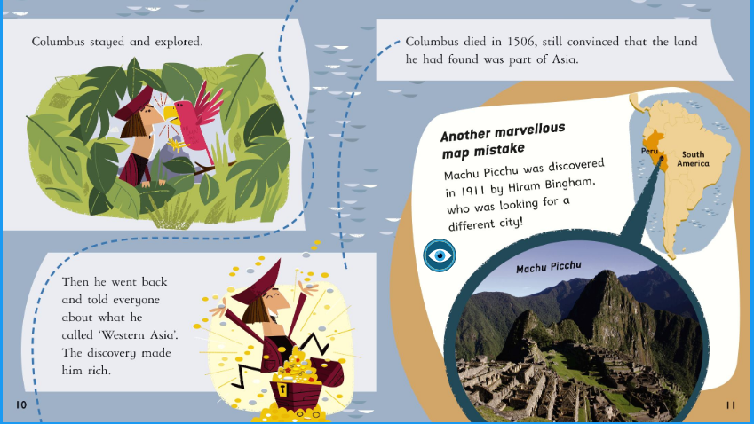
- What mistake had Columbus made?
- What did he call the continent that he landed on?
- Where is Machu Picchu?
- Why is Machu Picchu mentioned in this text?

Grammar
Watch these video clips and complete the tasks.

https://www.bbc.co.uk/bitesize/articles/zryxt39

Writing
Write a diary entry as if you are Columbus. Write about your jouney. Where were you going? How did you get there?
What did you discover? How did you feel?

Check it for mistakes.

