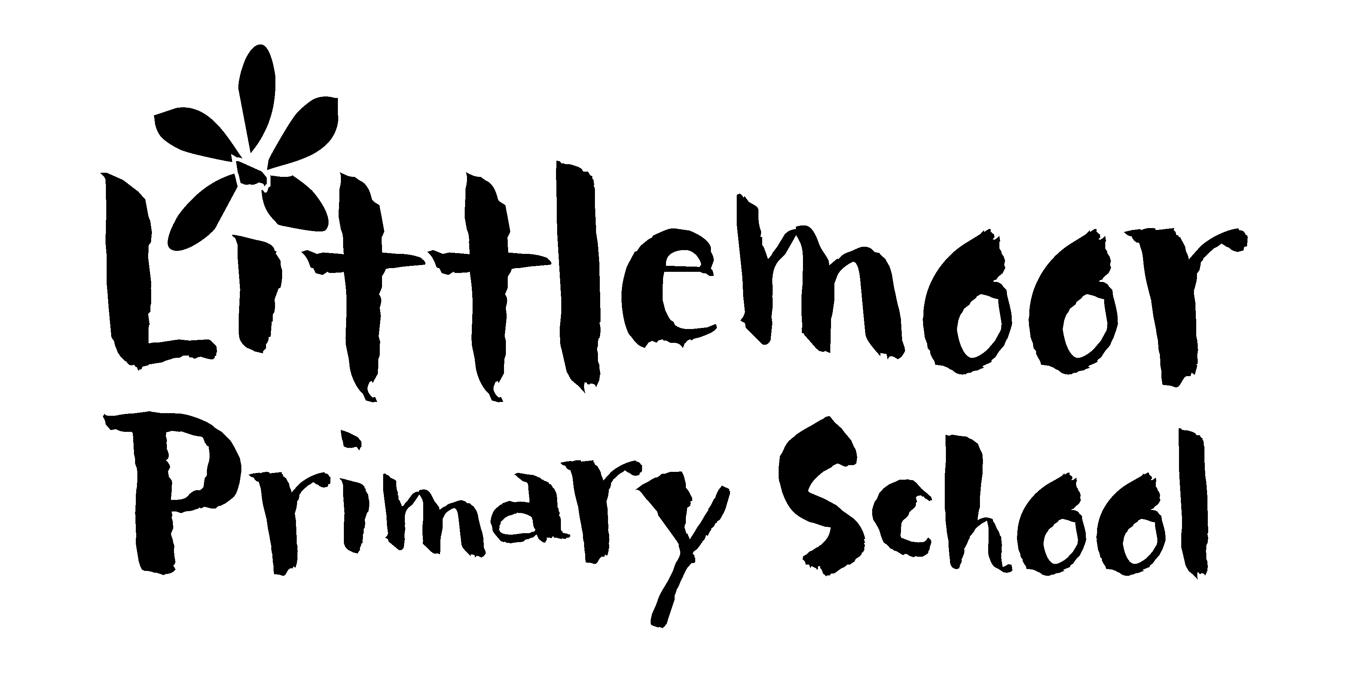

Friday 3 April 2020

Dear Parents/Carers

We are aiming to roll out vouchers in lieu of free school meals week commencing 20th April 2020.
This applies to children who are currently eligible for means tested free school meals only. Those parents will know who they are from earlier communications.

If your circumstances have recently changed and you think that you may now be eligible you need to apply via the Council urgently. The criteria as follows;

Means-tested free school meals

Eligibility

You can get free school meals if your child attends a local authority maintained school (not private) and you receive one of the following:
- Income Support (IS)
- Income-based Jobseekers Allowance (IBJSA)
- An income-related employment and support allowance
- Support under part VI of the Immigration and Asylum Act 1999
- Child Tax Credit (provided you are not entitled to Working Tax Credit) and have an annual income (as assessed by Her Majesty’s Revenue and Customs) that does not exceed the current year’s level
- the Guaranteed element of State Pension Credit
- Working Tax Credit during the four-week period immediately after your employment finished, or after you start to work less than 16 hours per week.
Universal Credit, provided you have an annual net earned income of no more than £7,400 (£616.67 per month) )

Link to the application form is
https://www.oldham.gov.uk/forms/form/525/en/free_school_meals_fsm_application_form

Kind regards
Mrs C Kelly

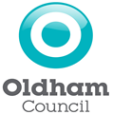

Headteacher: Mrs C Kelly B Ed Hons NPQH
Littlemoor Primary School, Littlemoor Lane, Oldham OL4 2RR T: 0161 624 4188
head@littlemoor.oldham.sch.uk www.littlemoor.oldham.sch.uk

